
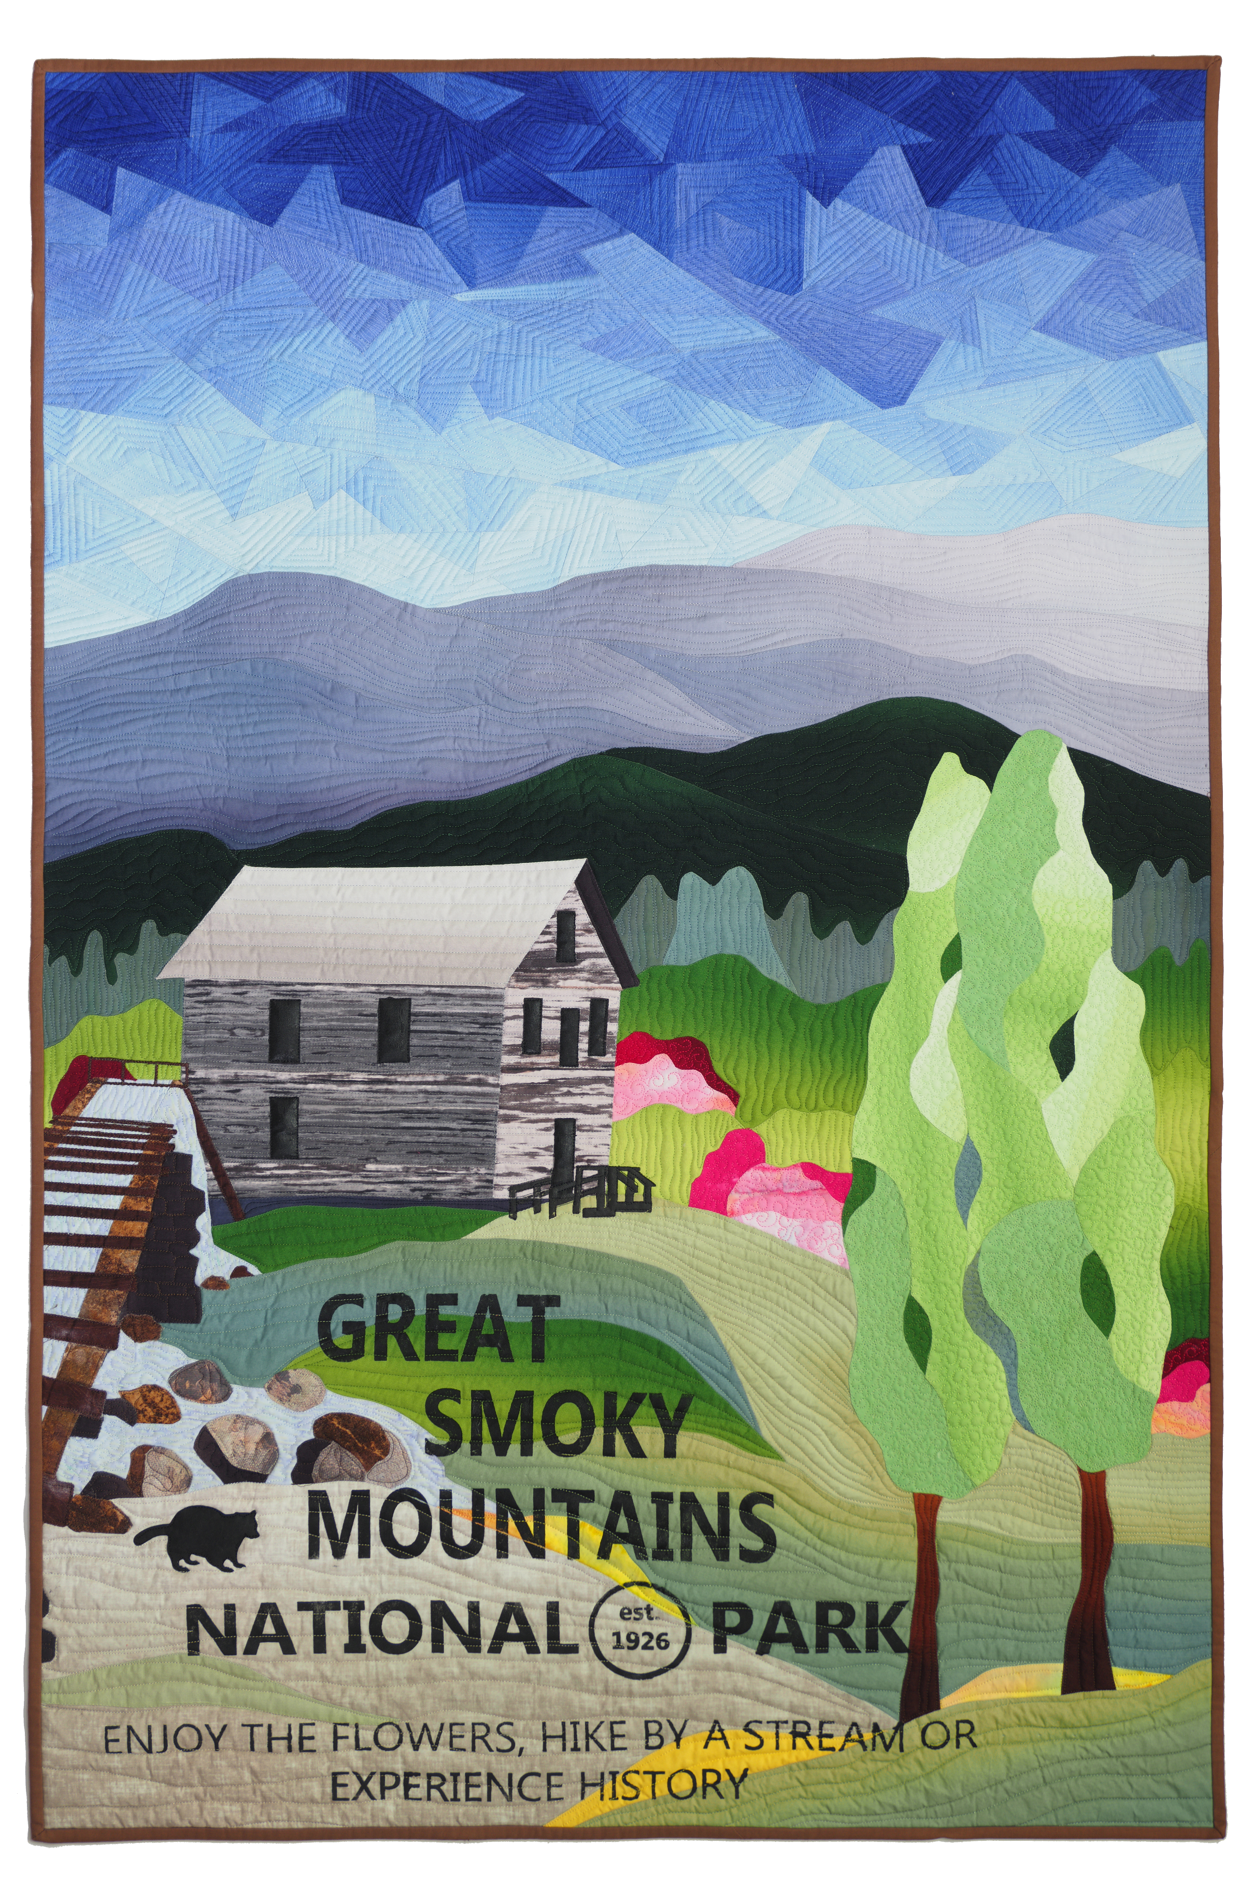
vickiconley55@gmail.com
https://www.vicki-conley.com/
Design from Photos to Imagination
In this class Vicki will show how she uses multiple photos to design a bold, graphic landscape. She will demonstrate simplifying the images using a tracing technique with clear sheet protectors or tracing paper as well as the drawing app Procreate on the iPad.
Then you will design your own pattern from your own photos. The finished pattern will be enlarged and traced on Floriani Stitch and Wash Fusible stabilizer. (Available from Vicki)
There will be a discussion about value and fabric selection.
You will construct a simple rock pattern to learn both the Turned Edge Machine Piecing and the Fussy Piecing for the sky. Then you will start on your own pattern. This is not applique, rather the pieces are sewn to each other, and the stabilizer stays in the finished piece.
On the final day Vicki will discuss and demonstrate different ways to print, stencil, or applique lettering onto quilts.
Vicki will be holding a pre class Zoom meeting to help you choose the right photos to use with these techniques. Please add vickiconley55@gmail.com to your contacts and watch for an email from her.
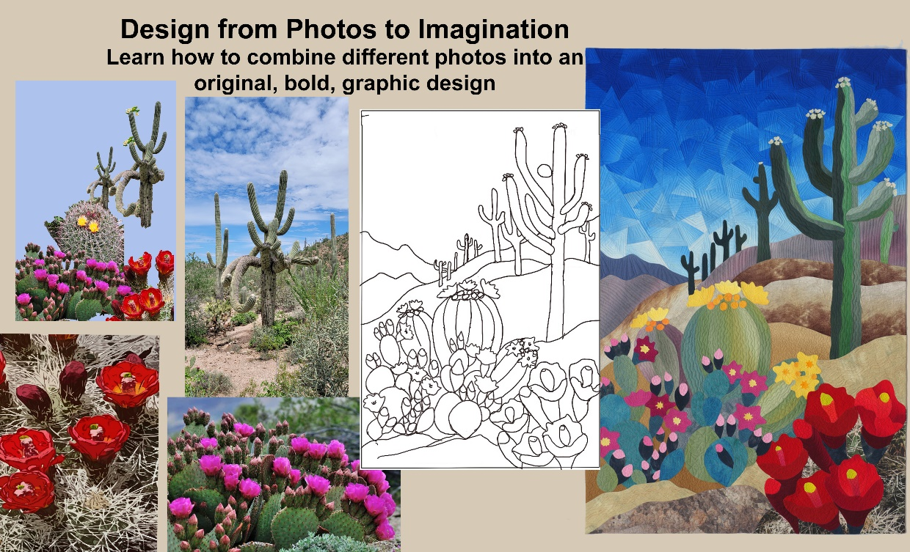
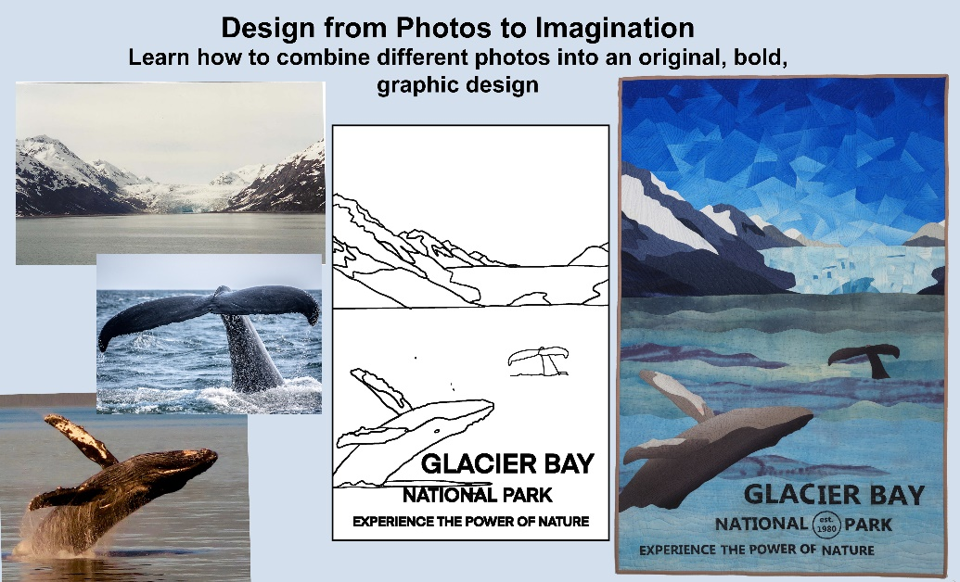

The supply list is below.

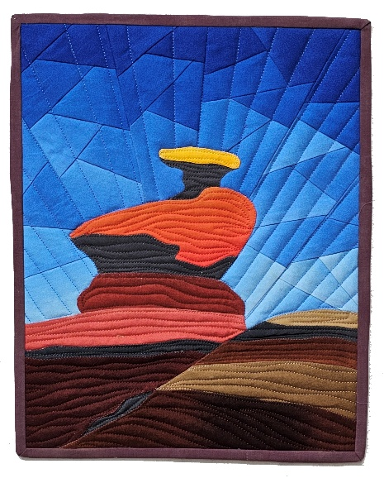 Small project to learn the techniques.
Supply List: Design from Photo to Imagination 3-5- day class
A selection of photos printed out 8.5 x 11.
IPad with Procreate installed or another tablet (optional). An Apple pencil or other stylus that works with your iPad. If you use an iPad have your photos in the gallery and printed out.
If you want to learn more about using your iPad for design please check out my class here.
Sketch book – no lines.
Pencil with eraser and Black Sharpies, fine point and regular point.
Scotch tape
Tracing paper
5 clear sheet protectors
Parchment paper
Freezer Paper
Iron /ironing surface.
Small mat and rotary cutter and ruler
Xacto knife or craft knife with new sharp blade. (Not Ceramic blade)
Scissors - fabric and paper
Colored pencils – NOT water soluble
2-3 Elmer’s washable glue stick (small not the fat one) ( Not the repositionable one).
Design wall or Foam core design board 20 x 30 and straight pins
Light box- this one is great value.
https://www.amazon.com/LITENERGY-Ultra-Thin-Adjustable-Streaming-Stenciling/dp/B07H7FLJX1/ref=sr_1_3?keywords=lightbox&qid=1641332339&sr=8-3
Sewing machine that does zigzag stitch with an open toe foot. A vertical free standing thread stand is helpful with the invisible thread. (if you want to bring a Featherweight you can do the zig zag stitching when you get home)
Small machine needles Microtex sharp 60/8 or 70/10 recommended for invisible zigzag, and average piecing needle. Also an open toe foot is very helpful as well as an extra table light.
Seam ripper and pins.
Optional Appliquick Tools https://www.amazon.com/Apliquick-Rods-Tools-Turned-Applique/dp/B07CGGK68Z
Stiletto
Piecing thread
Invisible clear thread – polyester –NOT nylon (Superior Monopoly or Sulky Poly) Both available on Amazon
To achieve a bold poster style solids or gradation solids are best. Various fabrics for your chosen landscape – lights mediums and darks. About 1 yard of gradation blue fabric for the sky. (Or 4 different values of blue solids)
Fabrics for the small mini rock quilt. They can be wild colors if you want.
Floriani Stitch N Wash fusible tearaway stabilizer – available for purchase from the teacher. ($4.00/yard) Or you can order an entire roll here. *FSWF2010 Floriani Stitch N Wash Fusible 20x10yds - 844050028221
My blue ombre fabric is available on Spoonflower.
vicki_conley's shop on Spoonflower: fabric, wallpaper and home decor
Other ombre fabrics can be found on Etsy. Maywood Fabrics also has nice gradations. Jenifer Sampou also has nice sky dyes gradations.
Please bring cash with change to buy the stabilizer. If there is no access to a printer you will need some money to pay a copy center to enlarge the pattern.

